LAB#3 WEB PROGRAMMING

CST8285 F2023



# LAB OBJECTIVE

The objective of this lab is to get familiar with the following:

1- Create a dynamic content using JavaScript

# Earning

To earn your mark for this lab, each student should finish the lab’s requirements, submit your lab on the Brightspace and demonstrate the working code to the instructor.

STATEMENT OF THE PROBLEM:

**Read the entire lab instruction before starting**.

This lab is to be completed on BrightSpace any lab worksheets handed in will be discarded. Carefully follow the procedures outlined in this lab worksheet. **If at any time you are unsure or are having problems, consult your lab instructor**.

## Part I: Making the Web Dynamic

In this lab you will take the provided JavaScript starter code and create an HTML5 compliant HTML page as well as a CSS file to format the page. You will be creating a random jokes generator that will use a provided array data structure full of Jokes. In the provided JavaScript starter code, you have a constant array of 10 jokes add to those ten jokes 5 more jokes at the end of the 10 provided jokes to get 15 jokes in total. (2 points)

## Part II: Building the Webpage

1. Create a new file called jokes.html and add the usual HTML5 boilerplate, including meta data to indicate you are the author of the code. The browser tab for your page should simply say “jokes” and you should include a header on your page that says : “Jokes to make you laugh”. (1 POINT)
2. Create a uniquely named div for the jokes and inside that div make another uniquely named div for the jokes text and under that a third uniquely named div for the author. You should have two uniquely identified divs inside of the first div. This way we can use CSS to format the whole jokes and also treat the jokes text and author names separately. These two inner divs should be empty as we will target them with our JavaScript to add our text in between their opening and closing tags. (0.5 POINT)
3. Create a centered button beneath these divs and add text such as “Get a Joke” to the button. We will create on click event handler to manually call a JavaScript function to grab a random joke from array. (0.5 POINT)
4. Create a new file called Jokes.css, link this file to your HTML page. (0.25 POINT)
5. Target the body element with the desired font stack for your page. You can use a

Lab#3 Web Programming

different font for each of the elements, but a good rule of thumb is to use one font for the page and only use a second one if you want to bring attention to a small portion of the page (such as a header). I chose a serif font for the title (header) , jokes text, and author. I also chose a sans serif font for the button text. You can choose any fonts you like, but you must use a **full** font stack for at least the body element. (0.25 POINT)

1. In the CSS file add a selector pointing to the outer div that will hold our jokes. Add a border with 15pt rounded corners to this div and give it a pleasant background colour. (0.25 POINT)
2. Format the elements that are on your page so that it looks something like the image below. We will deal with the jokes and author soon enough and you will likely want to tweak the CSS as you build the page. (0.5 POINT)

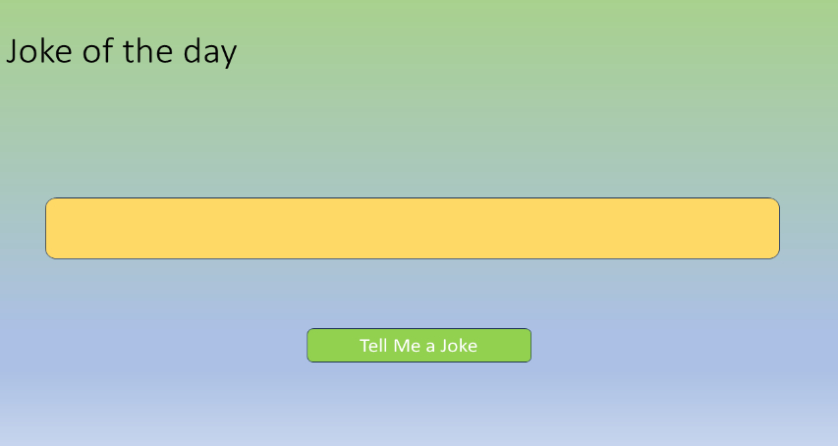

## Part III: Adding the JavaScript

1. In the JS file add an eventListener for the click button event, that will invoke a JavaScript function that you will create.

I called mine jokesArray().(0.25 POINT)

1. Open the provided Jokes.js file and start coding the click event handler code of the button element. Your function takes no parameters and will use the global constant jokesArray as its pool of jokes. (0.25 POINT)
2. Because arrays in JavaScript always start with an offset of 0 we can generate a random number based on the number of jokes in our array. This number will be from 0 to one less than the number of jokes. You will need to know a few things to write the code that dynamically generates this number:
   1. In JavaScript an array is an object that has a member value of length that returns the number of objects in an array. (0.5 POINT)
   2. To generate a random number, you use the random() function that is part of the Math object. This random() function will generate a random number from 0 to 1 that is never equal to 1. We can multiply this result by the total number of choices we want to select from and will generate a number from 0 to one less than our target number. (0.5 POINT)

Lab#3 Web Programming

* 1. Because random() gives us floating-point (real) numbers we use the function floor() (also in the Math object) to return the largest integer that is less than or equal to the given floating-point number. It is typical to wrap the results of random() in a floor() function. (0.25 POINT)

1. After you generate a random number you can use this number as an offset to get the jokes and author from the array. Put these values into the innerText value of the two divs inside your jokes div using simple DOM traversal. (0.25 POINT)
2. Make sure you link your script file to your HTML document.
3. Now you can test this function using a browser by pressing the button on your page. If your code is correct, then you should get a new random jokes with every click of the button.
4. When you are able to generate a jokes add embedded code to your HTML document that **calls** the function you created once when the page is loaded. Remember that the function needs to see the targeted elements in the DOM. This call will ensure that you always have a jokes in on the page even before you click the new jokes button. (0.5 POINT)
5. Format the jokes (CSS) so that the text is nice and large, well centered in the outer div, and that the author’s name is in italics as well as right justified inside the outer div. You can play with the padding and margins to make the jokes look great. (0.25 POINT)
6. Submit your code to an HTML validator ([https://validator.w3.org/)](https://validator.w3.org/) and take a screen shot of a properly validated HTML page, do the same with a CSS validator ([https://jigsaw.w3.org/css-validator/)](https://jigsaw.w3.org/css-validator/). (1 POINT)

## Part IV: Submitting your Work

When your code is complete, make sure you zip up all the files (**lab3 .zip**) created in this lab including a copy of any images that you have used in your growing website. (1 POINT)

* **Your modified version of the starter code (** jokes.js**).**
* **css** stylesheet
* **html** webpage
* **screenshots** of both HTML and CSS validation showing successful validation of code**.**
* **any images** used

Other Important Requirements

* Demo and justify your work and provide correct answer to professor questions. (2 POINT)
* The work will be graded zero if you do not demo it on time, even if upload